Holiday Greeting Card Publisher instructions
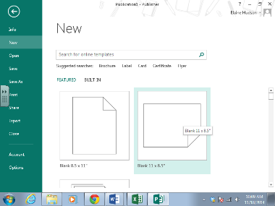
Open a blank document in Publisher

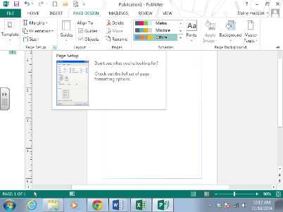
On the Page Design tab launch the Page Setup dialog box

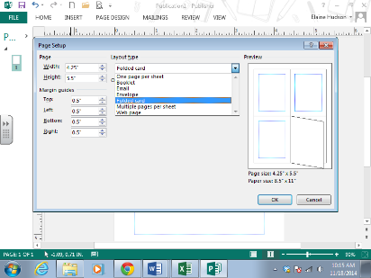
Change the Layout Type to Folded card

In the Sheet fold options select either Quarter-sheet side fold or Quarter-sheet top fold and click OK
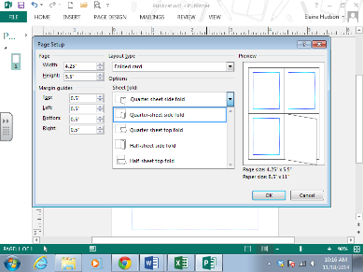

You should get the message below to which you will respond yes and begin designing your greeting card

Holiday Greeting Card Word instructions
Start a NEW document and select cards
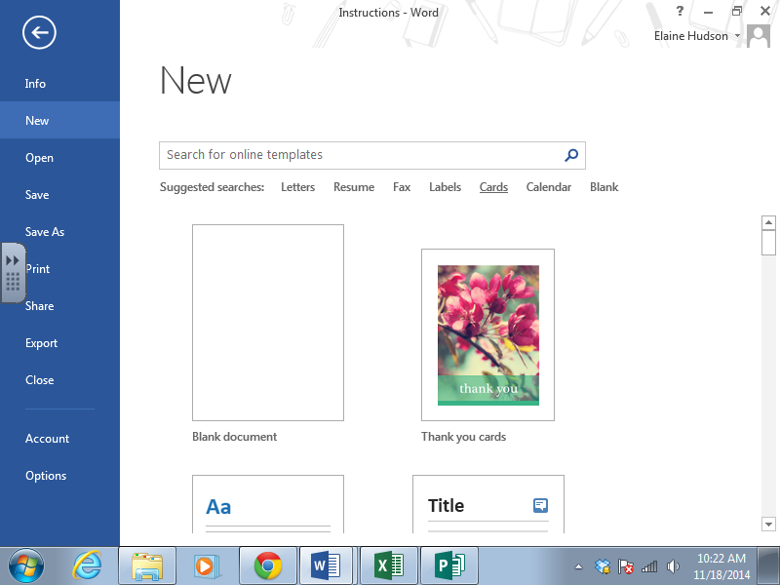
Select any quarter fold card
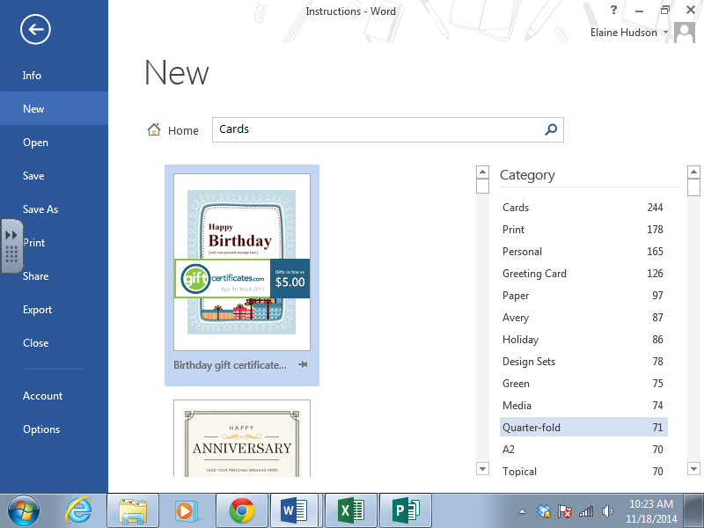
Edit it by deleting the template design and creating your own
